Being KIND to ourselves
Spending time together away from our screens is one of the most important things we can choose to do. Here are our suggestions for you to choose from.
Head outside together on a really cold morning to find cobwebs and tracks. What can you discover together? 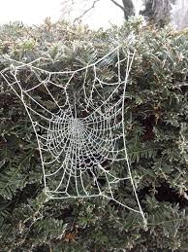 | Play a game of rounders or cricket together. Who shows the most courage in your game?  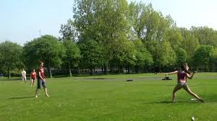 | Create a family message of kindness to post through a neighbour’s door.  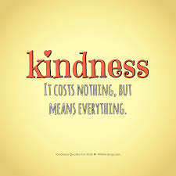 | Take a rainy day walk together – everyone in wellies!  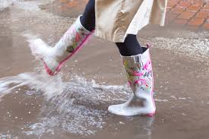 | Plant something new – seeds, bulb or a seedling.  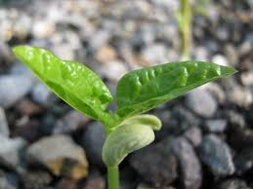
Write a family letter to someone else in your family. | Bake or make something you’ve never eaten before! | Play a board game in teams. | Take a walk to a different street and count your steps! | Re-use something plastic to create something new!  