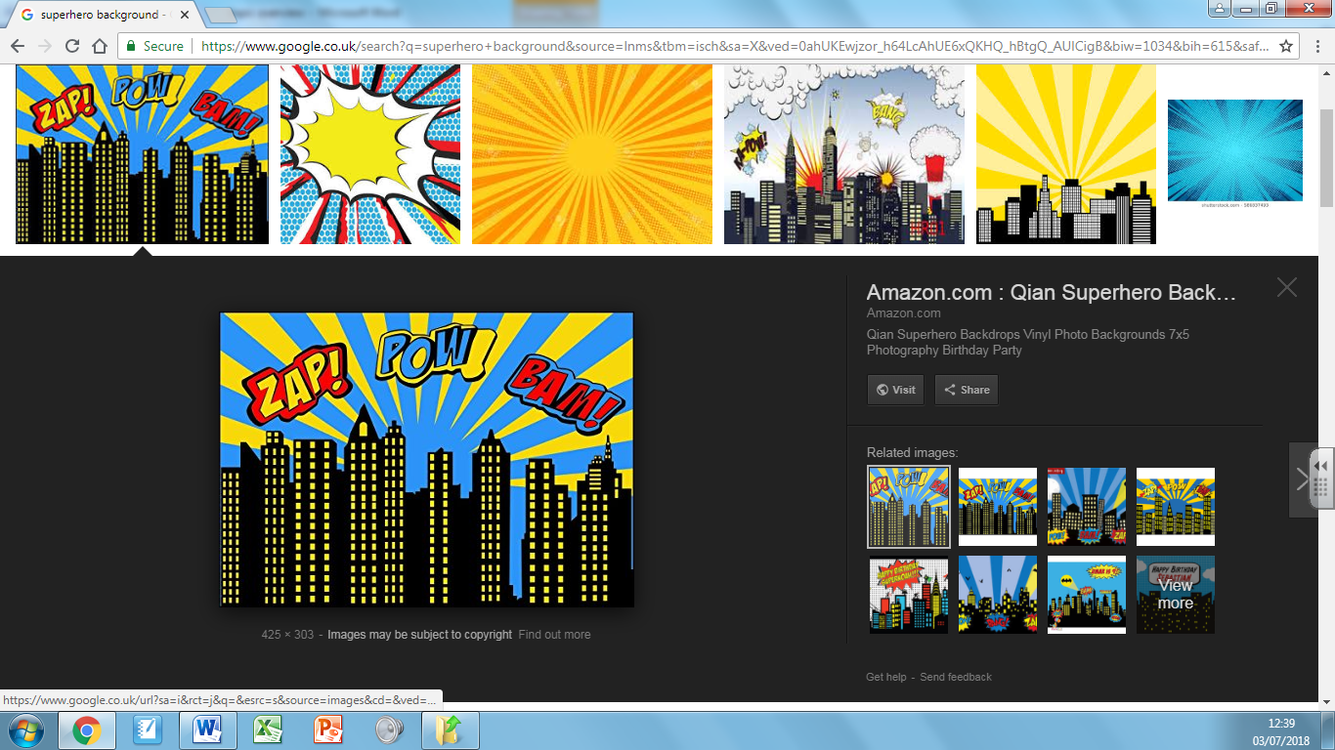

Art and DT

* Designing our own superhero mask and cape using paint and collage.
* Investigating colour mixing.

English

* Creating stories about superheroes.
* Inventing superhero potions and writing recipes for them.
* Superhero poetry.

PSHE:

* Children’s superheroes or special people in their lives.

Parental Involvement: Thurs 18thth Oct. 2.30pm: You are invited in for superhero crafts with your children.

Fab Finale: Thurs 18th Oct: Superhero dress up day! More details to follow.

R.E:

* Creation and Sacraments.

Maths:

* Place value using numbers up to 1000.
* Compare and order numbers, count in 50s and 100s and explore number patterns.
* Addition and subtraction working up to calculations with three digit numbers.

We are Superheroes!!

History:

* Heroes of the past and finding out how they changed the world around them.

Science:

* Forces and magnets. We will be doing lots of predicting and investigating.