Christ the King RC Primary School
Feedback and Marking Policy

Date adopted | July 2019 | Notes
Last reviewed | June 2018 | School Policy
Review cycle | Annually
Author/Owner | Governing Body
At Christ the King RC Primary, we recognise the importance of feedback as an integral part of the teaching and learning cycle, and aim to maximise the effectiveness of its use in practice. We are mindful also of the research surrounding effective feedback and the workload implications of written marking.
Our policy is underpinned by the evidence of best practice from the Education Endowment Foundation and other expert organisations. The Education Endowment Foundation Research shows that effective feedback should:
- Be specific, accurate and clear
- Encourage and support further effort
- Be given sparingly so that it is meaningful
- Provide specific guidance on how to improve and not just tell pupils when they are wrong.
- Put the onus on students to correct their own mistakes, rather than providing correct answers for them
- Alert the teacher to misconceptions, so that the teacher can address these in subsequent lessons
Notably, the Department for Education’s research into teacher workload has highlighted written marking as a key contributing factor to workload. As such, any feedback should be: Meaningful, Manageable and Motivating.
Key Principles
Our policy on feedback has at its core a number of principles
- The sole purpose of feedback should be to further children’s learning;
- Feedback should empower children to take responsibility for improving their own work.
- Children should receive feedback either within the lesson or in the next appropriate lesson – verbal or written.
- Children are given time to respond to feedback as appropriate.
- Teachers should ensure they ‘Teach, revisit, revisit, revisit’ to take account of the ‘forgetting curve’.
- Written comments should only be used where they are accessible to pupils according to age and ability;
- A wide range of Assessment for Learning (AfL) strategies are used to give feedback based on the EEF model, e.g. modelling, cueing, prompting, questioning, self and peer assessment, marking station, whole class marking, tickled pink / grow green teacher marking, etc.
- Teachers use AfL to plan next steps in learning.
Within these principles, our aim is to make use of the good practice approaches outlined by the EEF toolkit.

Feedback and Marking in Practice
It is vital that teachers evaluate the work that children undertake in lessons, and use information obtained from this to allow them to adjust their teaching. Feedback occurs at one of four common stages in the learning process:
- Immediate feedback – at the point of teaching
- Summary feedback – at the end of a lesson/task
- Next lesson feedforward – further teaching enabling the children to identify and improve for themselves areas for development identified by the teacher – tickled pink, grow green comments and purple pen for improvement.
- Summative feedback – tasks planned to give teachers definitive feedback about whether a child has securely mastered the material under study
These practices can be seen in the following practises:
Type | What it looks like | Evidence (for observers)
Immediate | - Includes teacher gathering feedback from teaching within the course of the lesson, including mini-whiteboards, bookwork, etc.  - Takes place in lessons with individuals or small groups  - Often given verbally to pupils for immediate action  - May involve use of a teaching assistant to provide support or further challenge  - May re-direct the focus of teaching or the task | - Lesson observation/learning walks
Summary | - Takes place at the end of a lesson or activity  - Often involves whole groups or classes  - Provides an opportunity for evaluation of learning in the lesson  - May take form of self or peer-assessment against an agreed set of criteria steps to success (S2S) / Remember To  - May take the form of a quiz, test or score on a game | - Lesson observation/learning walks  - Some evidence of self and peer-assessment  - Quiz and test results may be recorded in books or logged separately by the teacher.
Feedforward: ‘the next step is the next lesson’ | - Teachers will give time for development areas to be worked on and improved through proof reading and editing their work.  - Misconceptions are addressed by using effective AfL during lessons, in subsequent lessons and pupil conferencing. | - Lesson observation/learning walks  - Evidence of progress in pupils’ books as a result of Grow Green comments (verbal or written) and purple pen editing / corrections by pupils, challenge stickers.  - WALT / S2S highlighted in pink when achieved.
Summative | - ‘Check it’ activities  - End of unit or term tests or quizzes  - Gap analysis of tests | - Check it activities in books  - Quiz and test results

Appendix 1

The strategical minimal marking triangle
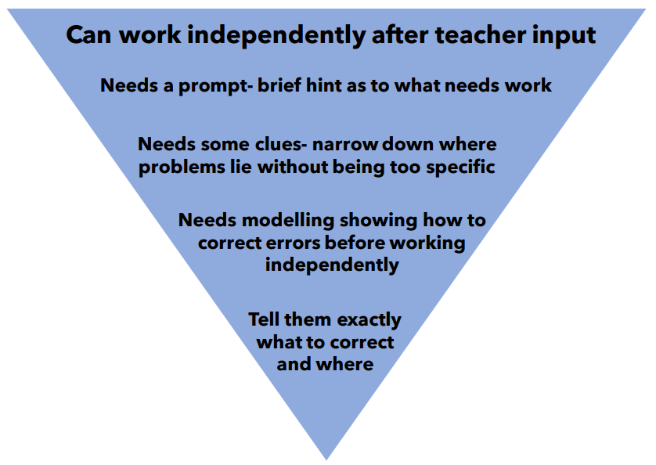

Start out with the assumption that all children can work independently given prior input and only increase the amount of intervention if the pupil really can’t get on without it. Give children take up time; let them struggle for a bit, but above all, make sure they are the ones doing the hard work; not you.

Appendix 2

The Forgetting Curve
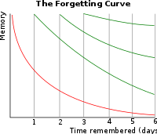

Appendix 3
Optional Marking Symbols See Phase Specific Charts
Key Stage 1
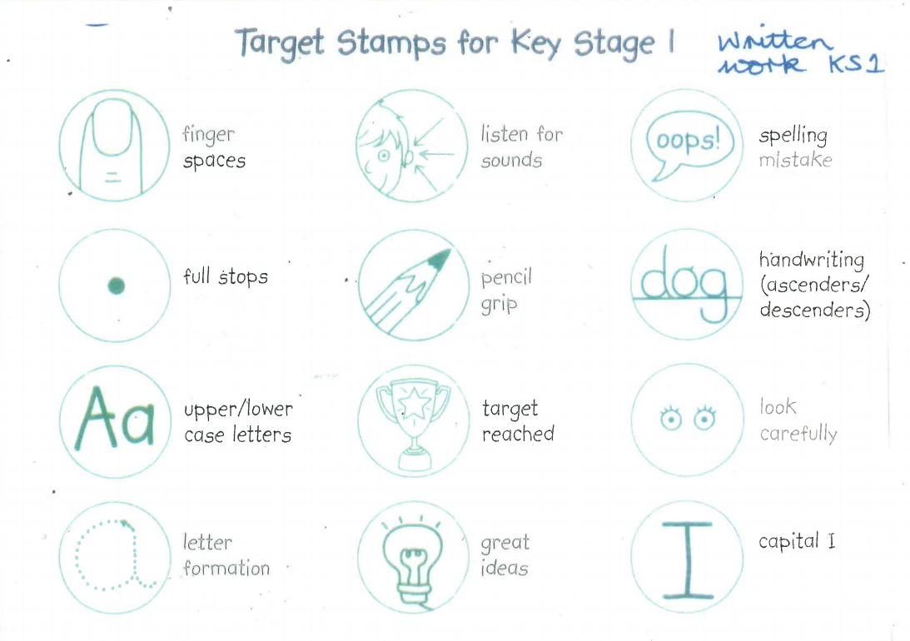
In addition to this Key Stage 1 will also use ^ to show an omission.
Teachers may wish to record VF for their own records, but this is optional. Verbal feedback should be evident by the pupil’s responses in purple pen.

Lower Key Stage 2
Sp – Spelling The incorrect spelling is underlined and the children are expected to write it out 3 times
next to the teacher’s example at the bottom of the page.
CL – Capital Letter The incorrect use of a CL or a missing CL is underlined in the text.
FS – Full stop The incorrect use of a FS or a missing FS is underlined in the text.
P – punctuation The incorrect use of p or missing p is underlined in the text.
t- tense
^ - to show an omission.

- Improve and up-level this word
Teachers may wish to record VF for their own records, but this is optional. Verbal feedback should be evident by the pupil’s responses in purple pen.

Upper Key Stage 2
Sp – Spelling Sp written in the margin on the line where the spelling error occurs. Children are expected to
locate and correct the spelling independently.
CL – Capital Letter recorded in the margin.
P – punctuation recorded in the margin.
t- tense
RW - Rewrite
NL – New line
^ - to show an omission.

- Improve and up-level this word.
// - New paragraph

Teachers may wish to record VF for their own records, but this is optional. Verbal feedback should be evident by the pupil’s responses in purple pen.

Appendix 4
Glossary of Terms
- WALTs - ‘We are learning to’. These are recorded and displayed for every lesson. WALTs are recorded in books and highlighted pink when they have been achieved.
- S2S - Steps to Success may also be referred to as REMEMBER TOs, these are generally generated with the children during the lesson. High 5 Hand is used in Reception. High 5 Hand is also used in Year 1 along with Maths Mitt and Super Steps.
- TARGETS - Children refer to targets as ‘next steps’. Children need to know their next steps in Reading, Writing and Maths. The Targets may be recorded on a bookmark or card; they may have a group or class target.
- Visualizer – a magnifying IT device used to model learning.
- Tickled Pink – positive comments or highlighting to show achievement.
- Grow Green – comments or highlighting to show areas for improvement.
- Black pen marking – identifies marking carried out by support staff.
- Purple pen for improvement – pupil editing and correcting pen.
- EEF – Education Endowment Foundation

