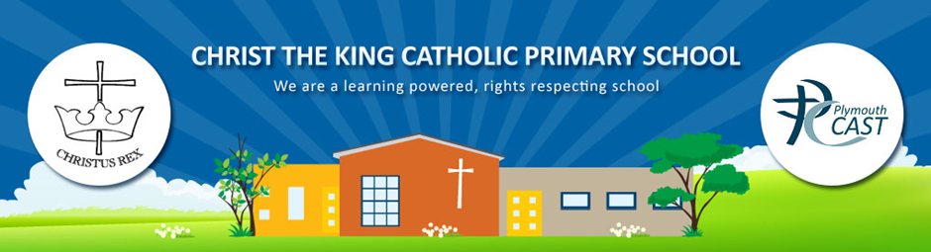
Maths Policy
At Christ the King School we believe that maths is a fundamental part of the learning experience of our pupils.

We aim for our pupils
- To develop the ability to think clearly and logically, with confidence, flexibility and independence
- To develop the ability to apply knowledge, skills and ideas in real life contexts outside the classroom and become aware of the uses of mathematics in the wider world.
- To develop personal qualities such as perseverance, independent thinking, cooperation and self-confidence through a sense of achievement and success.
- To develop a deeper understanding of mathematics through a process of enquiry and investigation.
- To foster a positive attitude to mathematics as an interesting and attractive part of the curriculum
- To recognise the importance of maths in their own lives;
- To achieve their age related expectations, at least in line with national percentages.
For our families
- To recognise that children’s ability to understand maths is best fostered through a partnership between home and school.

Through this policy we aim to:
- Ensure consistency of approach throughout the school;
- Outline the range of mathematical experiences offered to pupils.

Teachers will:
- Use the National Curriculum and the Early Years Foundation Stage Curriculum as the basis for the teaching of Maths throughout the school.
- Include a daily mental maths focus.
- Use apparatus to introduce/reinforce and extend understanding of mathematical concepts.
- Give regular feedback including response in books, peer feedback and challenge prompts.
- Emphasise the development of strategies for mental calculations as well as formal methods.
- Ensure pupils are given opportunities to explore and investigate in order to acquire necessary knowledge, skills and understanding and apply their learning in a range of contexts.
- Teach formal written methods for addition, subtraction, multiplication and division in KS2.
- Enable and empower children through a range of teaching strategies such as questioning, problem solving, modelling, games, whole class/ small group/paired and individual tasks.
- Take into account children’s strengths and their specific individual special needs.
Parents will:
- Ensure the completion of home learning tasks for mathematics and support where necessary.

Pupils will:
- Work to the best of their ability within the lessons.
- Respond to teachers feedback.
- Complete their home learning tasks on time.
Governors will:
- Monitor the attainment and progress of all children in Mathematics
- Devise strategic plans, alongside the Headteacher to ensure Mathematics teaching and learning is of a consistently high standard
- Work closely with the subject leader to monitor all aspects of Maths.

Cross Curricular Links with Mathematics
Mathematics is not seen as a subject in isolation, but one that naturally occurs in all areas of the curriculum:

Mathematics contributes significantly to the teaching of English. Pupils enjoy stories and rhyme that rely on counting and sequencing as well as encountering mathematical vocabulary, graphs and charts when using non-fiction texts.

During science lessons, pupils are able to use and apply their data handling skills when creating tables and graphs of scientific measurements. Whole class discussion of data also highlights the importance of clear recording of information. Pupils are required to use a wide range of measuring devices in a real-life context and read the scales, which will also apply to other subjects such as Design Technology and Food Technology.

During P.E. lessons children can directly learn the relevance of timing, direction and working systematically through first-hand experience.

In History and R.E. pupils need to apply their understanding of the passage of time to learn about different people, places and events.

Pupils use and apply mathematics in a variety of ways when solving problems in computing, through understanding symbols, commands and creating programs. When working on control, pupils will need to use directional language and to use standard and non-standard measures for distance and angle. They use simulations to identify patterns and relationships.

Mathematics contributes to the teaching of personal, social and health education and citizenship. We present pupils with real-life situations in their work, such as the spending of money.

Statutory End of Key Stage Assessment.

The National Curriculum requires that each child is assessed, and assigned a Level of attainment for Mathematics. This is to be carried out at the end of Key Stage Two.

Early Years Foundation Stage (EYFS)

Mathematics within the EYFS is developed through purposeful, play based experiences and will be represented throughout the indoor and outdoor provision. The learning will be based on pupils’ interests and schemas or current themes and will focus on the expectations from Development Matters / Early Years Outcomes. 2 As the pupils progress through, more focus is placed on representing their mathematical knowledge through more formal experiences. Pupils will be encouraged to record their mathematical thinking when ready and this will increase throughout the year.

Children’s progress
This is monitored and evaluated using a range of assessment methods.

Formative Assessment (AfL) - (monitoring children’s learning)

The class teacher and support staff make formative assessments daily as it is an integral and continuous part of the teaching and learning process. Teachers integrate the use of formative assessment strategies such as: effective questioning, clear learning objectives, the use of success criteria, effective feedback and response in their teaching and marking and observing children participating in activities. Findings from these types of assessment are used to inform future planning.

Summative assessments
Summative assessments, sometimes in the form of tests, take place termly.

Assessment Weeks:

We use termly assessments as a way of recording children’s progress in objectives covered across that specific term. Children’s progress is carefully tracked and discussed regularly with class teachers. Queries about individual children’s progress should, in the first instance, be raised with your child’s class teacher.

Ratified November 2015
Re-ratified 28th February 2017
To be reviewed: February 2019

