We wish you all a relaxing break over Easter. Classes have not set formal home learning, other than reading and times tables but here are some Easter projects we think your children may enjoy (we’d love you to send us photos via Twitter/eschools):
Easter is the biggest celebration in the Church’s liturgical calendar. Holy week begins with Palm Sunday on 5th April https://www.tentenresources.co.uk/sunday-liturgy-for-families/
You might like to mark this special day by making palms to decorate your front door 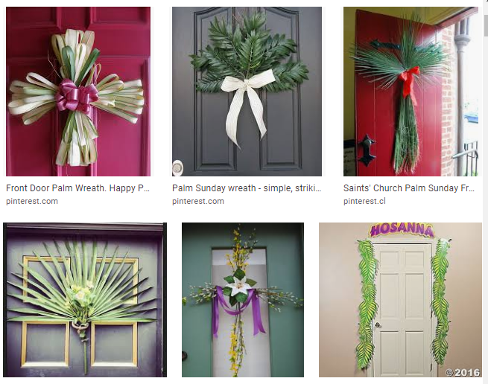
www.tentenresources.co.uk/daily-prayers-for-home Please use this link for prayers to say and read during Holy Week.

Easter baking projects: https://www.bbcgoodfood.com/howto/guide/fun-easter-projects-kids
There are lots recipes based on the Easter theme on the website above.
Retell the Easter story – useful resources to explore first:
https://www.bbc.co.uk/teach/class-clips-video/religious-studies-ks1-the-christian-story-of-easter/zhgv47h
https://www.bbc.co.uk/cbeebies/stories/lets-celebrate-easterperformance?collection=lets-celebrate-stories
https://www.bbc.co.uk/bitesize/topics/ztkxpv4/articles/z4t6rj6
Afterwards, you all could make an Easter garden using plants, peg dolls and pebbles:
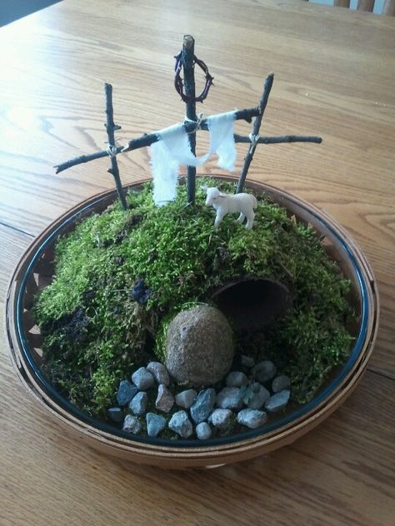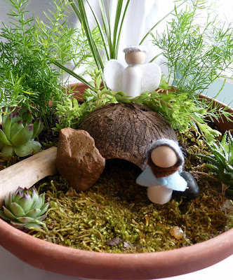
Create some Easter art work:
Or, maybe.....
- Make a gratitude/kindness jar and wrote a note/draw a picture every day of something you are grateful for. Read them when you need cheering up!
- Start a small container garden with a mix of strawberries, blueberries, spring onions, spinach, radishes, lettuces, tomatoes, etc. (They’re easy to grow in recycled plastic containers.) This teaches children about life, responsibility, science, patience, nutrition, and sustainability.
- Children can write an autobiography, focusing on this unique time in their lives.
- Play indoor volleyball with balloons—it’s great for a wet day!
- Design a vehicle that can transport a hard boiled egg safely from one point to another.
- Design a device that will protect a hard boiled egg when it is dropped from a height.
- Write a recipe for a delicious Easter treat... or try following a recipe to make your own.
- Make a comic strip based on the Easter story.
- Build an Easter egg / bunny using Lego or other construction toys.
- Design an Easter card to send to a friend
- Find out how Easter is celebrated in different parts of the world. Could you create a news report or an ebook to teach others what you discover?
Enjoy the break. We look forward to seeing some photos of your Easter projects on Twitter/class pages. In the meantime, keep safe and well, look after each other!
From everyone at Christ the King

