CHRIST THE KING CATHOLIC PRIMARY SCHOOL
Headteacher: Mrs Clare Tickel
Deputy Headteacher: Mrs Francesca Perry
Assistant Headteacher: Mrs Melanie Lord
Durdells Avenue Kinson Bournemouth BH11 9EH Tel.(01202) 574277
Fax. (01202) 594114 e-mail: christtheking@ctkcps.com
Diocese of Plymouth, registered charity number: 213227
Website: www.ctkcps.com

School Council wellbeing newsletter
Dear children,
This is the School Council’s first wellbeing newsletter! We have included activities to help you to improve your wellbeing and stay positive

Wellbeing quote of the week
‘If you have good thoughts they will shine out of your face like sunbeams and you will always look lovely.’ –Roald Dahl

Apple Dorset Cake
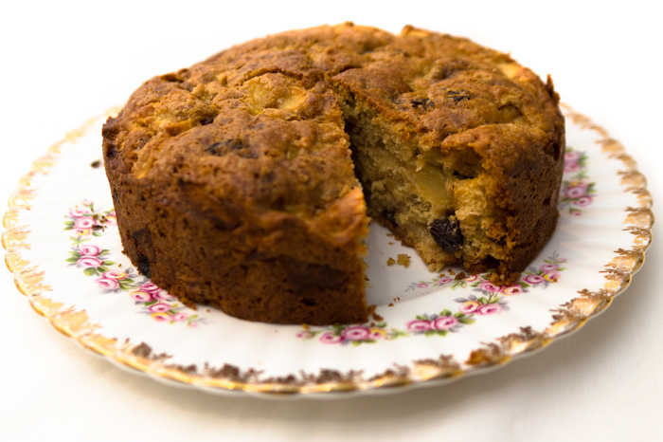
This delicious treat is sure to make your taste buds tingle! It’s a great comfort food and can be served with cream or custard. The apple dorset cake originated in dorset, as its name suggests. It is definitely one of my favourite desserts and I bet it will be one of yours too!

Ingredients:
115g Butter,diced and chilled, you may need extra
For the tin.
225g self raising flour.
2tsp ground cinnamon (unless,like me, you like extra,add another tsp!),
115g light brown sugar,
1 large egg, beaten,
6-8tbsp milk,
225g of the apple of your choice,

- Set the oven to 180C/160C fan/gas 4. Butter and line a deep 20cm cake tin with baking parchment.

- Mix the flour and cinnamon together in a large bowl. Add the butter and rub it into the flour until it starts to crumble into breadcrumbs .Stir in the light brown sugar.

- Beat in the egg, followed by 6-8tbsp of milk- add slowly and gradually, until you have a smooth,thick(and delicious) batter.

  - 4.Add the apples and mix to combine. Scrape the batter into the prepared tin, and gently level out.

- Bake for around 30-40 minutes or until your cake is golden brown, insert a skewer into the middle of the cake, if it is clean when it comes out, your cake needs to be placed cautiously onto a baking tray and left to cool,after 15 minutes in the tin.

- Enjoy your cake!! It doesn’t matter if it isn’t perfect, or it’s burnt a bit, mine never come out perfect! I hope you enjoy this recipe, because I really do :) .

Activities to do at home

Go for a bike ride or a  walk | Make a paper maiche puppet  ]]]
Play a board game with your family | Take part in scavenger hunt  