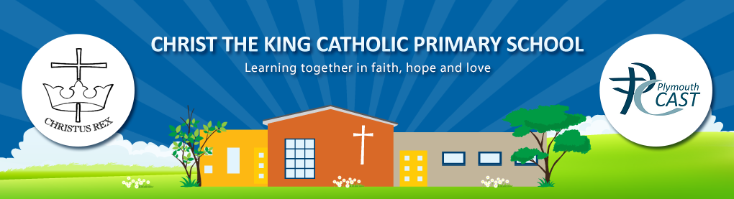January 2025

**Christ the King RC Primary School RE and Catholic Life News**

Dear Parents and Carers,

Just when we thought the celebrations might stop after Christmas, the New Year started with a month full of significant Church calendar events. What’s more, [the Year of Jubilee](https://www.iubilaeum2025.va/en/giubileo-2025/segni-del-giubileo.html) has begun! This special celebration year comes with an invitation from Pope Francis to place our hope in God’s love for us and to share His love with others.

**A Gift for Jesus**

The Celebration of the Word assembly for the first week of term celebrated the Epiphany of the Lord. This is when Jesus was revealed to the Wise Men after their long journey following the star.

Through this, children will reflect on how God the Father gave Jesus as a gift for us all. They will also consider what gifts they can offer Jesus, such as their time and attention.

After spotting clues in a painting of the Wise Men meeting Jesus, children used their imaginations to join with these wise travellers on their journey to see the baby King for the first time.

**Jubilee Joy: Open**  
January begins our series themed around the Holy Year - Jubilee Joy. Starting on the 27th of January and continuing later in Lent, these assemblies will encourage children to join with the Church in celebrating the joy of the Jubilee and consider some of its key themes.   
  
As a natural follow on from our Advent preparations, this assembly explores how being open to God, and the hope He brings us can help children in growing their friendship with Him. It’s a time to restart, as well as a time for resting with and worshipping God!  
  
Children will hear about Jesus' mission and reflect on the open invitation to join Him in sharing the hope of God by becoming ‘Pilgrims of Hope’ during the Year of Jubilee.  
*With your child, perhaps..*

1. *Read the Sunday Gospel (*[*Luke 4:14-21)*](https://www.biblegateway.com/passage/?search=Luke%204%3A14-21&version=NRSVACE) *and talk with your child/ren about how Jesus then lived out His mission on Earth through prayer and action.*
2. *Think about how you can spend time resting with God. You might like to go for a gentle walk together or create a quiet space in your home to rest and pray.*   
     
     
     
   **WHAT IS IT YOU WANT ME TO DO?**  
     
   The Gospel for the week of the 20th of January reflects on the wedding in Cana. When the wine had run out for the guests, Mary instructed the servants to “Do whatever He tells you.” *(John 2:5)*   
     
   Inspired by these events, children will spend time in prayer looking at an area in our lives and asking Jesus, ‘What is it you want me to do?’, then praying for the strength to do it!  
     
   You might like to try some contemplative prayer in your family prayer time, simply resting in the love of Jesus. You can do this by playing some music or repeating a phrase in your mind to help you focus as you pray together.   
     
   Perhaps you’d like to use this prayer to finish:  
     
   **Jesus,**   
     
   **Give me the strength to do whatever you tell me to.**  
     
   **In the name of the Father, and of the Son, and of the Holy Spirit.**   
     
   **Amen**

Advent started right at the beginning of December this year. It’s a special time of year and more than just the ‘busy run up to Christmas’. Why not take some time, amongst all the busyness, preparations and celebrations that anticipate the coming of Jesus, to pause, reflect and get ready to welcome Jesus with open minds, open hearts and open lives.

This newsletter shares some of the content children have experienced in school throughout December and suggests ways for you to engage with them about it. We hope it is a useful resource for your family prayer time.

**Mass and Liturgies**

We are most grateful to Fr Patrick Crystal who was able to say mass for us in the school hall, to mark the beginning of Advent. Sadly, due to the ingress of water, the church is completely out of use at the moment. We hope to be able to have our school masses in the church again soon.

.

**Julia’s House**

**Year of Jubilee**

**Let Us Pray**

**We give thanks for:**

* Our school, for our teachers and staff, who all work together to support our children.
* The Jubilee Year, and the opportunities that it will bring for us to become closer to God.
* Our clergy and parish communities.

**We pray for:**

* Our church that we may soon have a parish priest to lead our parish and school.
* All those who are sick, especially those dear to us who are receiving end of life care, may they be comforted with faith, hope and love.
* World leaders who are working to bring peace to Nations around the world.
* We pray especially for Fr Chacko and ask that he returns to full health.

**And finally, may we all be Pilgrims of Hope**.

Kind regards and God Bless,

Melanie Lord

Deputy Headteacher

   