CtK PTFA Update 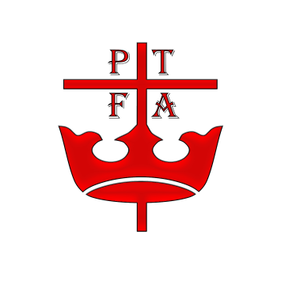

● Bingo Night – Tickets are limited and sold on a first come first served basis
● Entry is by ticket only
● Doors open at 6pm. First game will start at 6.30pm prompt
● Food must be ordered and paid for by 23rd March
● Fabulous Prizes of Chocolate Hampers
● Refreshments and tuck shop

● Easter Bonnet Parade is on Wednesday 3rd April at 2.45pm in the school Hall – everyone is welcome

● Easter Colouring Competition - Entries to be returned by Monday 1st April

